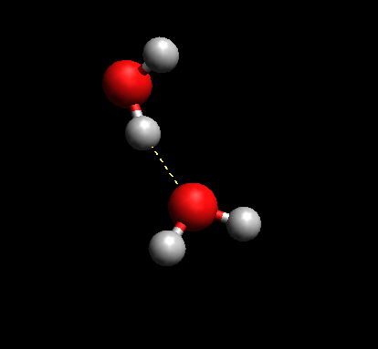

Fig 1. shows the hydrogen bonds between one oxygen and a hydrogen of another molecule. This happens as oxygens electronegativity is much larger than that of hydrogens.

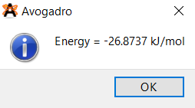

Fig 2. Energy value of Fig. 1 configuration computed in Avogadro

Fig 1. Water hydrogen bonding between two molecules

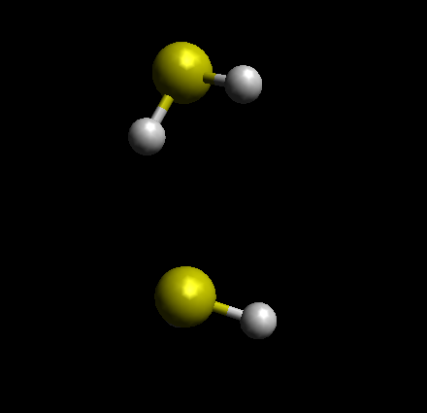Fig 3. shows that no hydrogen bonds form between one sulphur and a hydrogen of another molecule. This happens as sulphurs electronegativity is on par with hydrogens.

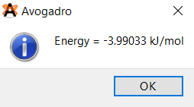

Fig 4. Energy value of Fig. 3 configuration computed in Avogadro

Fig 3. H2S has no hydrogen bonding between two molecules

Fig 5. shows that 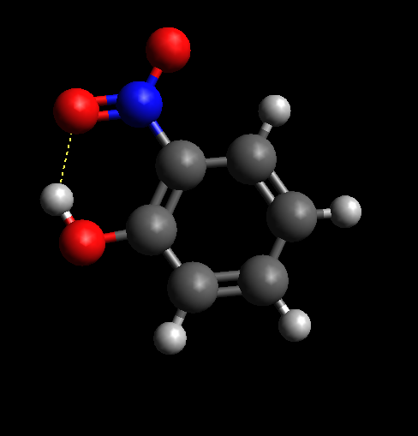a hydrogen bonds forms between the hydrogen in phenol and the oxygen in the nitro group. This happens for the same reason as water, oxygen and hydrogen has a high difference in electronegativity.

Fig 6. Energy value of Fig. 5 configuration computed in Avogadro

Fig 5. o-nitrophenol hydrogen bonding within itself